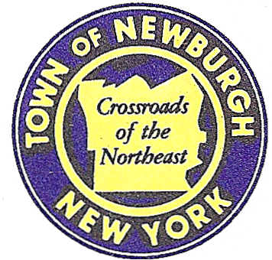

TOWN OF NEWBURGH
_______Crossroads of the Northeast __________________________
OLD TOWN HALL
308 GARDNERTOWN ROAD NEWBURGH, NEW YORK 12550

PLANNING BOARD
JOHN P. EWASUTYN, CHAIRMAN
TELEPHONE 845-564-7804
FAX 845-564-7802
E-MAIL: planningboard@townofnewburgh.org

PLANNING BOARD AGENDA

September 7th, 2017

*PLEASE NOTE: The Planning Board Meeting will start at 7:00 P.M. and all Applicants/Representatives
are to be present at that time. The Meeting will be held in the Meeting Room of Town Hall,
located at 1496 Route 300, Newburgh NY.*

- Mobilite(17-23) INITIAL APPEARANCE
6 Orr Avenue

Section 96, Block 1, Lot 11.1
Zone: IB
Rep: Paul Costa

- US Crane & Rigging (17-11) INITIAL APPEARANCE
18 Route 17K AMENDED SITE PLAN
Section 97, Block1, Lot 21.2
Zone: IB
Rep: Maser Consulting, P.C.
555 Hudson Valley Avenue, Suite 101
Newburgh, NY 12550

3. Diamond Properties-OCC Site Plan (17-20) AMENDED SITE PLAN
14 Crossroads Court

Section 95, Block 1, Lot 74 & 47.2
Zone: IB
Rep: Cudy & Feder, LLP
300 Westgate Business Center Suite 380
Fishkill, NY 12524

*WORK SESSION*
Project Readiness Discussion scheduled for 5:30 p.m. in the Meeting Room of
Town Hall on Thursday, September 7th, 2017.*

4. Lakeside Senior Housing (16-19) PUBLIC HEARING
Route 32
Section 75, Block 1, Lot 29.1
Zone: IB
Rep: Talcott Engineering Design, PLLC
1 Gardnertown Road
Newburgh, NY 12550

PLANNING BOARD BUSINESS
WORK SESSION

- Ironworkers Local 417 (15-02) – Requesting a 6 month extension from September 7,
2016 to March 7, 2017

*WORK SESSION*
Project Readiness Discussion scheduled for 5:30 p.m. in the Meeting Room of
Town Hall on Thursday, September 7th, 2017.*

